How to Register on the Thompson Ringette Uplifter Site
It’s important that your player is registered online, even if you registered in person. You will be on the team emails, and we can better track the collection of Ringette fees.

- Go to thompsonringette.ca and choose login

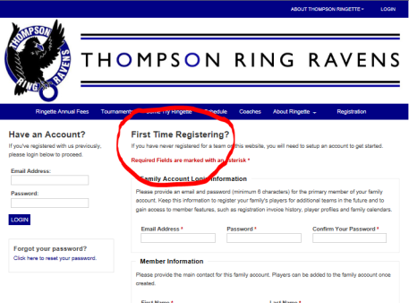
- If you don’t have an account already, fill in the information under ‘First Time Registering?’. Member Information is about you as a parent, who will receive emails and the receipts will be in your name.

- The ‘Players’ section is for adding information about each player who will be registering. You only do this once.  Leave the ‘Coach’ field as ‘No Coach’. This will be determined by the team that you sign the player up to.  (You can also check a box to indicate that you will be registering as a player) | 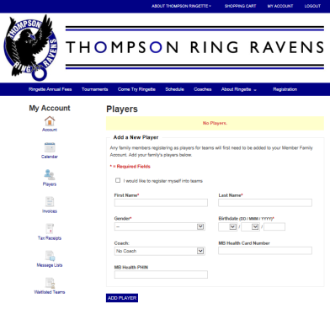
- To register a player on a team, go to ‘Registration’ from the main page (you must be logged in). | 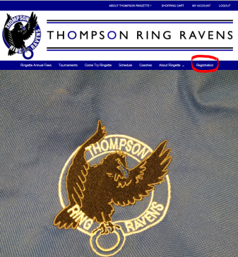
How to Register on the Thompson Ringette Uplifter Site (p.2)

- The Registration page will look like this. Click the ‘Register’ button for the team you want to register a play with.  If you have multiple players on your account, the site may ask you to choose the player to register for each team. | 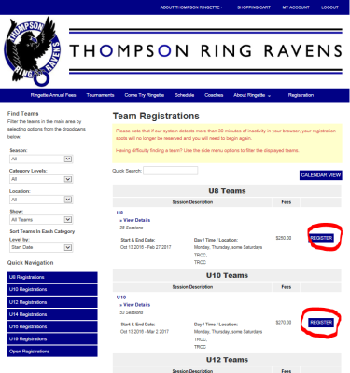
- After assigning a player to a team, the shopping cart shows that you have items in the cart. | 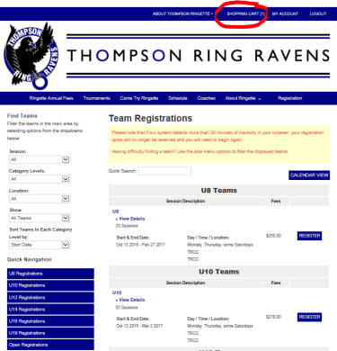
- The Shopping Cart gives you a chance to confirm, edit or delete items in the cart before choosing ‘Confirm & Register’. | 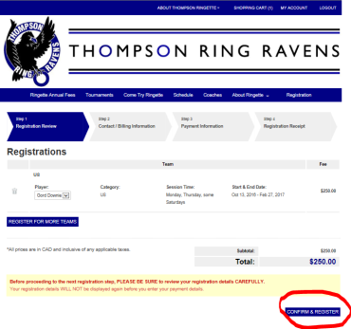
- You’re not done yet! Because we are only taking payments offline, you need to confirm that you will pay in person. | 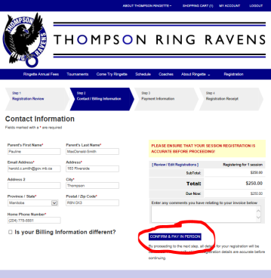
- Once you choose ‘Confirm & Pay in Person’, you will receive an invoice by email.

